WIMBLEDON VILLAGE SURGERY April 2024

NEWSLETTER
A warm welcome to all patients to our new monthly newsletter. We would like to use this opportunity to provide you with relevant information about the practice, keep you informed on practice development, staffing and services and to encourage your feedback and comments about our practice. We hope to make these newsletters as interactive and as informative as possible – all feedback is warmly received!
Thank you and good bye! A fond farewell to the retiring Dr Paul Cundy. March 31st was a poignant day in the history of the practice as we said goodbye to the long-serving Dr Cundy. After some 35+ years, Dr Cundy decided it was time to retire from GP work the practice Partnership and take up a life filled with planes, renovations and automobiles! We know he would like us to pass on his farewells to each and every one of his patients, who will likely miss him just as much as we do.
Out with the ‘old’ in with the new!? Dr Cundy’s departure has obviously created a space within the workforce. We are pleased to announce the arrival of Dr Nicola Walker to the team. She is a very experienced GP, having relocated to the area. We are delighted she has chosen to work with us and to pick up the baton. If Dr Cundy was your ‘usual GP’, you will need to be moved to an alternative GP. You will receive a text message from the practice with more specific information on this.
Paramedic Practitioner Services We would like to extend a warm welcome to our new Paramedic, Lauren Rixon. She has joined us to help provide additional assessment and treatments in a wide range of urgent, acute or minor illnesses
‘Under New Management’ The practice has recently experienced some transition with the Practice Management structure. Following the departure of the previous manager, we now have a new Practice Manager – Craig Stanley – who joined just before Christmas and will be with us up until the end of 2024. We have also recruited a Deputy Practice Manager, Rob, to assist with and manage the day to day Operational functions of the practice. Further to this, we have just recruited a new Reception Lead to manage the reception and administrative team and we look forward to welcoming her to the team in the next couple of weeks.
Vacancies The following role(s) is/are vacant and we are actively looking to recruit as soon as possible:
Practice Nurse 24 – 32 hours per week to work alongside our existing, excellent nursing team. Anyone interested in this role can find the full job advert on NHS Jobs (Job Advert (jobs.nhs.uk)) or on Indeed (Practice Nurse - Wimbledon - Indeed.com)
Patient Participation Group (PPG)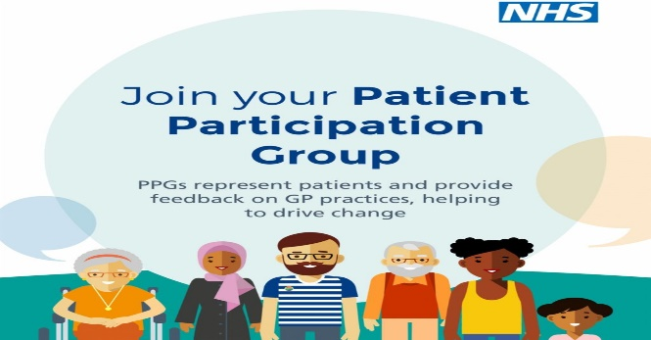
The practice would like to re-establish a patient PPG to help us to help you. PPGs are an important and integral part of the practice in being a ‘voice’ for our patients and to assist in ensuring the services we provide – whether clinical or administrative – are up to standard. We would like patients to get involved with the practice to attend meetings, manage feedback, promote services in the community and advise us of the wider patient perspective, running volunteer services and support groups to meet local needs. If you would like to be a member of our PPG, please contact us at wimbledon.villagesurgery@nhs.net entitling your email with ‘PPG’ and for the attention of the Practice Manager.
Health Promotion We will post various health promotion content here in the newsletter, relating to ‘hot-topics’ or National Campaigns currently running. This month we would like to highlight the following:
Testicular cancer awareness
Cancer of the testicles is one of the less common cancers and tends to occur in men aged 15 to 49.
If you have lumps, swelling, hardness, pain or heaviness in your testicles, it could be a sign of a number of conditions. Among the more serious is testicular cancer. So, if you’re worried about any of these symptoms, a visit to your GP should help you to get to the bottom of it. https://www.testicularcancernetwork.co.uk/april-testicular-cancer-awareness-month
https://www.nhs.uk/conditions/testicular-cancer/

Complaints, Compliments, Suggestions and Comments
We appreciate that sometimes the service provided can fall short of your expectations and it common nature to write to a company or service provider to make a complaint, but we don’t often do so when we have good things to say. We would like encourage you all to write to us with your positive experiences of us and your compliments – these go a long way to keeping us all motivated and happy! Please write to wimbledon.villagesurgery@nhs.net with your compliments, complaints or suggestions!

